Data Analytics with Tableau

Assignment – 1

Bar Chart:

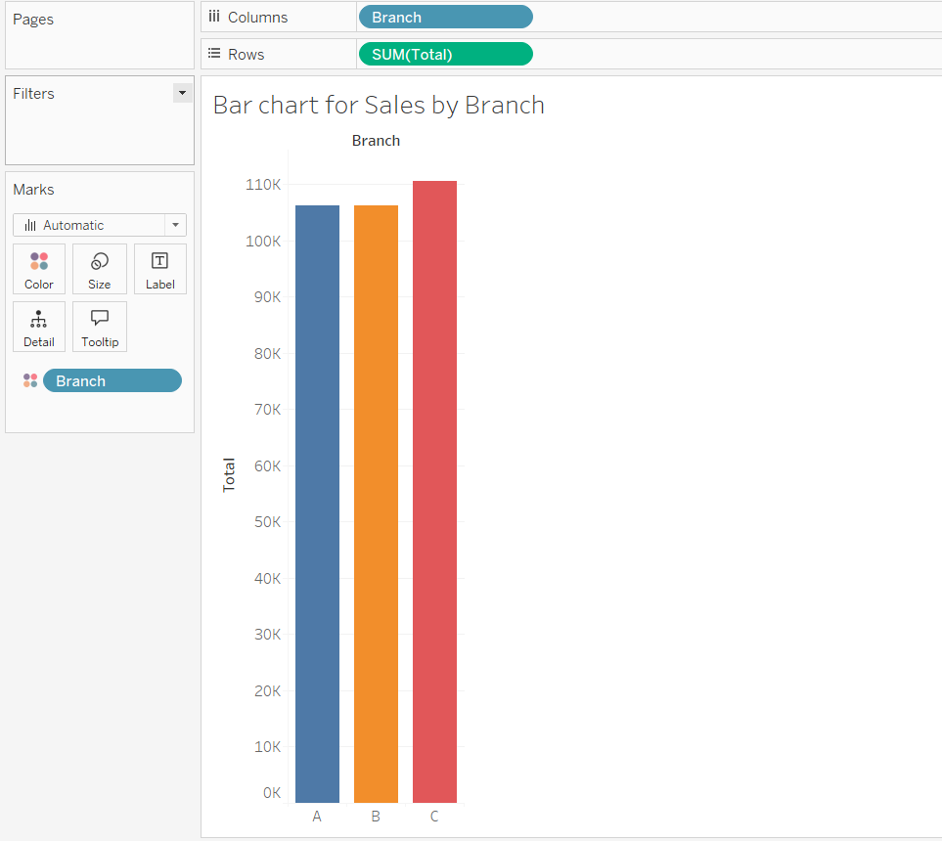

Pie chart:

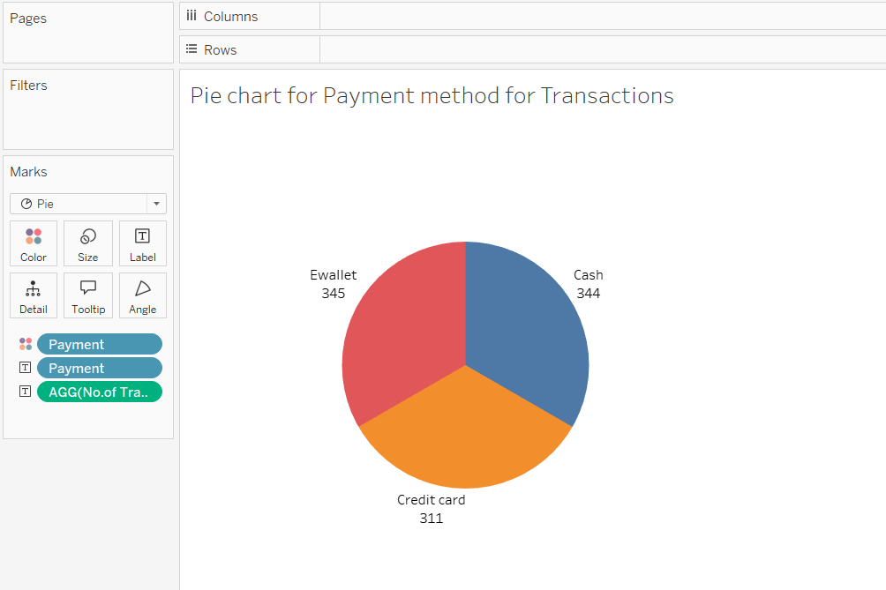

Stacked Bar Chart:

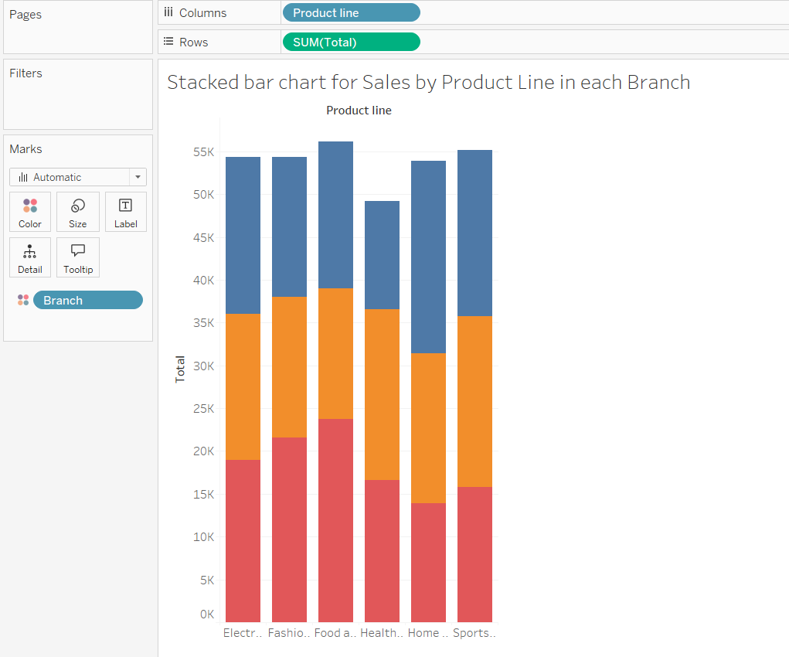

Line Chart:

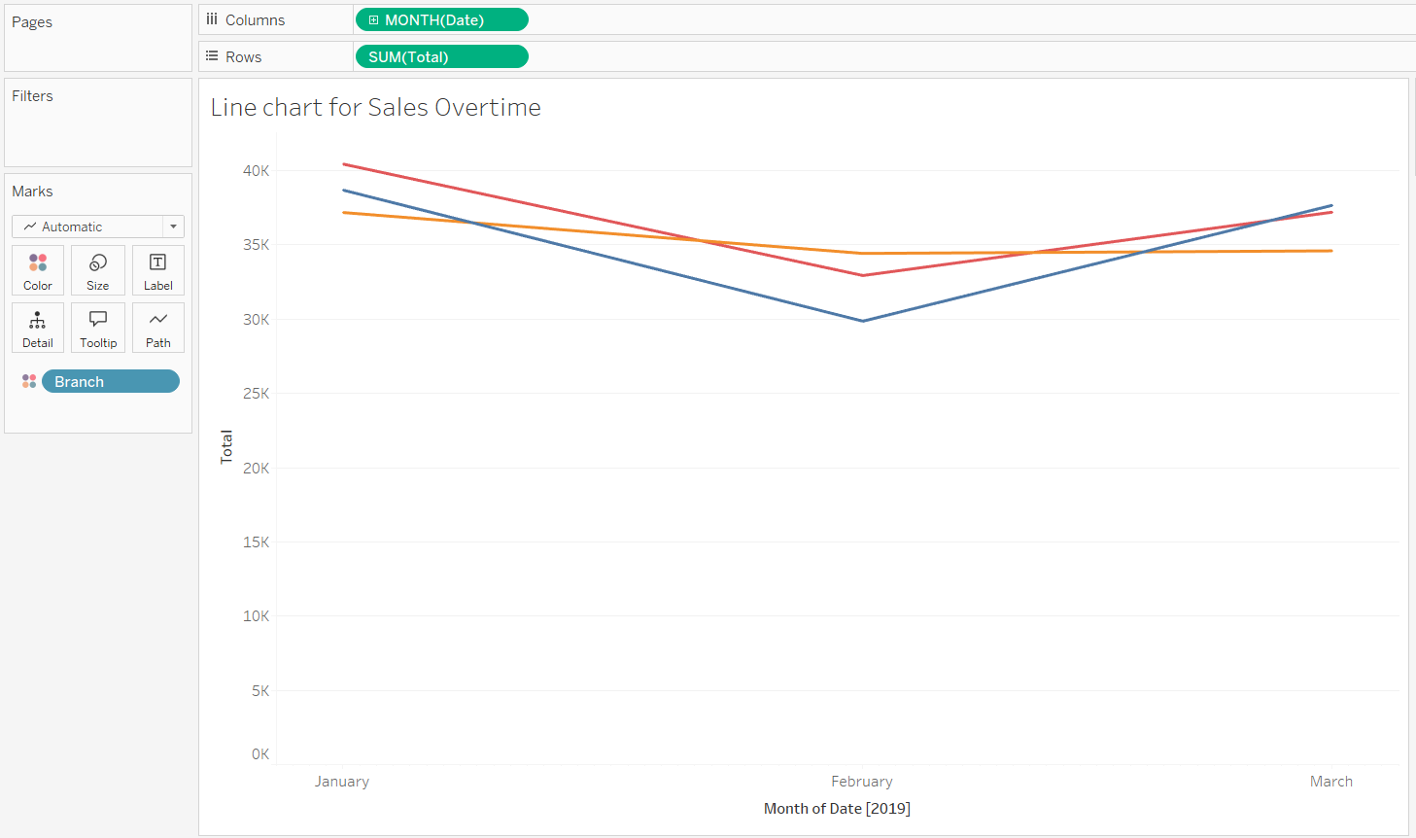

Bubble Chart:

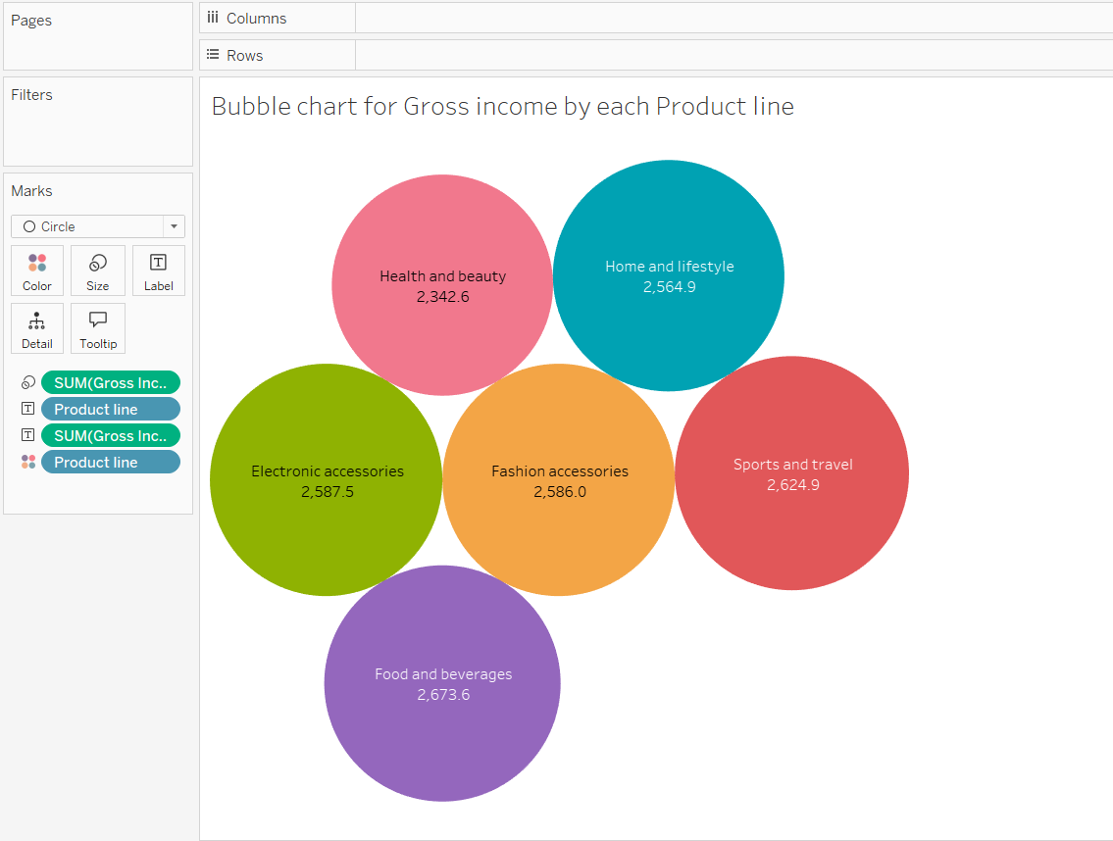

-P. Bhanu Prabhavi